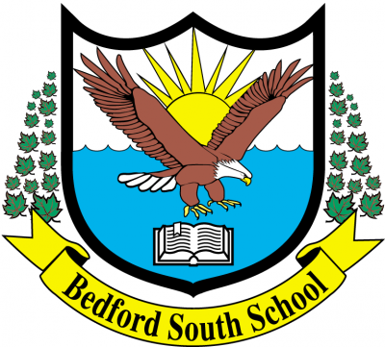
October 14 2025- Minutes
Bedford South SAC
Attendees: Joniada Milla, Adam Greenwood, Katie Rand, Karla McInnes, Tracy Foster, Jane Taylor, Inbal Vichansky, Dayle O’Neil
- Welcome
Tracy welcomed everyone to the meeting.
- Approval of Minutes of June 10th meeting
Approved.
- SAC Membership for 2025-26
We still need one more community member. Karla and Dayle will post in their neighbourhood Facebook groups to advertise the role.
SAC conference is November 28th.
- Administrative Report
We have 747 students to date and 33 classes. All classes are either at or close to the CAP. Grades 3/4/5 are all at hard CAP. P-2 are close to CAP. We are getting 2-4 students registering per week and some leaving per week so numbers are staying around the 750 mark.
Lunch Monitors: We would like to have 16 lunch monitors but only have 8. Admin staff have been filling in. Karla and Dayle will post the link to the HRCE job ad in their neighbourhood Facebook groups as well.
The lunch program is cooked in house now and the meals have been really good. Meals are hot and fresh and the students seem to enjoy them.
We have held two fire drills, one lockdown drill and one Hold and Secure drill. All went well. A bus evacuation drill will be held in the near future (all students).
Behaviour / School Culture: Every morning on the school announcements we talk about behaviour expectations and our vision statement. We also teach about bus expectations, and the behaviour has been good.
Truth & Reconciliation assembly will be held next week. We will hold two sessions so we have enough space in the gym.
Student Success Plan (SSP)- Every school in the province has to have an SSP for literacy, math and well being. The goals for each topic are the same throughout the province but each school develops their own strategy to reach the goals. Bedford South School strategy:
Math strategy: all teachers will incorporate 30 mins of fact fluency. We have a math coach until November who has been coaching teachers in the classroom.
Literacy strategy: Making the connection between reading and writing. Teachers will use books and students will make written responses.
Well-being: Vision statement and setting common expectations using common language.
We received our results from last year’s provincial assessment. Our scores were: 73% met for reading, 63% met for writing, 77% for math. These are slightly better than the regional average for scores.
Student Code of Conduct has been updated this year, and we have been using it to respond to behaviours. It has been going well and the clarity for addressing behaviours in the new Student Code of Conduct has been helpful.
Concerts: Our winter concert in November will be for grades P-3 and our spring concert for 4-5 / strings / choir.
- Innovation Grant
We were not chosen for the innovation grant last year but will continue to build on the same idea we had to apply again this year. We will refine the idea and rewrite the application. The goal will be to update our library into a learning commons and enhance our EAL collection / tools.
- SAC / Healthy Schools Grant
We will use the SAC grant to buy Chromebooks for the school again this year.
- Meeting schedule for rest of year
November 18th , February 10th, April 14th, May 12th, June 9th.

- Any other business
No other business.

